
2026 Northwest District Meeting

Falling Into The Holidays
Wednesday, October 7, 2026
First United Methodist Church- Fellowship Hall
167 Joe Bowling Road, Clinton, AR 72031
SPEAKER: Terry Williams, Interior ASID

Hosted by: Iris Garden Club

The Northwest District Meeting of the Arkansas Federation of Garden Clubs, Inc. will begin with registration at 9:30 a.m. The business meeting will Call to Order at 10:00. Following the luncheon, Terry Williams, Interiors ASID, with 45 years of experience in interior design, Professional member of American Society Interior Designers and is a state licensed interior designer and former Governor appointed member of the AR Interior Design Licensing Board, will present our program.

Each Club should bring 2 priced items for Ways and Means. The Ways and Means Table and Iris Club Gift Shop will be open during registration, at the lunch break and after the meeting with lots of holiday items.

Directions: Map and directions are on the back with lodging options.
Call our Registrar, Carol Oakland, with any questions. 501-652-0500

>>>Cut Here >>>>>>>>>>>>>>>>>>>>>>>>>>>>>>>>>>>>>>>>>>>>>>>>>>>>>>>>>>>>>>>>>>>>>>>>>>>>>>>

2026 NORTHWEST DISTRICT MEETING REGISTRATION FORM
Make checks payable to: Iris Garden Club

Registration Fee: $25 includes lunch (postmarked by September 17th) Late Fee: $30 at the door
Mail to Registrar: Carol Oakland, 234 Citation Drive, Clinton, AR 72031

Name ___________________________________ Email _____________________________

Address _________________________________ Garden Club_________________________

City/State/Zip ____________________________ Phone _____________________________

Check all that apply: State President ( ) State Past President ( ) District Director ( ) State Officer ( ) State Chairman ( ) National Officer ( ) Club President ( ) Club Member ( ) Circle of Roses ( ) AFGC Life Member ( ) First Time Attendee ( ) Guest ( )

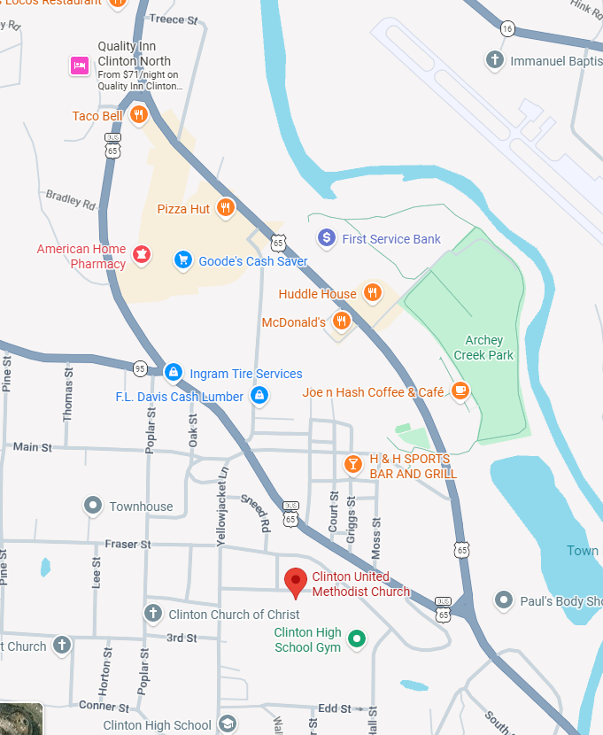

Directions:
On US 65:

From the North, turn right on 65 Business, turn right on Main St, immediately turn left on Yellowjacket Lane, then Left on Joe Bowling to Church.

From the South, turn left on 65 Business, turn left on Main St, immediately turn left on Yellowjacket Lane, turn left on Joe Bowling to Church.

Lodging:
- Super 8 Motel (By Walmart) 2008 Hwy 65S, Clinton, Arkansas 501-745-8810
- Best Western Hillside Inn, 125 HWY 65 Business, Clinton, across from Exxon Station 501-745-4200
- Many motels in Conway, AR. 45 minute drive to Clinton.

